भारतमौसमविज्ञानविभाग |  | India Meteorological Department
Thursday,12th June 2025 (22 Jyeshtha 1947 Saka)
Summary of observations recorded at 0830 hours IST: The Northern Limit of Monsoon continues to pass through 17.0°N/55°E, 17.5°N/60°E, 18°N/65°E, 18.5°N/70°E, Mumbai, Ahilyanagar, Adilabad, Bhawanipatna, Puri, Sandhead Island, 23.5°N/89.5°E, Balurghat, 30°N/85°E. Conditions are favourable for further advancement of Southwest monsoon over some more parts of Central & adjoining East India (including some more parts of Vidarbha, Chhattisgarh & Odisha) during next 48 hours. An upper air cyclonic circulation lay over Punjab & neighbourhood at 0.9 km above m. s. l. The trough ran from the cyclonic circulation to southeast Madhya Pradesh across Haryana, west Madhya Pradesh at 0.9 km above m. s. l. An upper air cyclonic circulation lay over west Uttar Pradesh & neighbourhood at 1.5 km above m. s. l. An upper air cyclonic circulation lay over west Rajasthan & neighbourhood between 1.5 & 3.1 km above m. s. l. The upper air cyclonic circulation over westcentral Bay of Bengal off north coastal Andhra Pradesh coast lay over north coastal Andhra Pradesh and adjoining south Odisha & which extended upto 5.8 km above m. s. l. titling southwestwards with height. A trough ran from the cyclonic circulation to coastal Karnataka across Chhattisgarh, Marathwada, Interior Karnataka between 3.1 km to 5.8 km above m. s. l. The Western Disturbance as a trough in middle tropospheric westerlies with its axis at 5.8 km above m. s. l. ran roughly along Long. 62°E to the north of Lat. 28°N. The upper air cyclonic circulation over east Uttar Pradesh became less marked. The upper air cyclonic circulation over north Haryana & Chandigarh lay over Haryana of yesterday evening. It then became less marked today morning.

Day temperatures were markedly above normal (> 5.1°C) at many places over Jammu-Kashmir Ladakh-Gilgit-Baltistan-Muzaffarabad; at most places over Arunachal Pradesh; at few places over Assam & Meghalaya and Himachal Pradesh; at isolated places over sub Himalayan West Bengal & Sikkim, Gangetic West Bengal, Bihar, west Uttar Pradesh, west Rajasthan, east Rajasthan, west Madhya Pradesh and east Madhya Pradesh. appreciably above normal (3.1°C to 5.0°C) at many places over east Uttar Pradesh; at most places over Haryana-Chandigarh-Delhi and Punjab; at few places over Nagaland, Manipur, Mizoram & Tripura; at isolated places over Odisha and Tamil Nadu, Puducherry & Karaikal. above normal (1.6°C to 3.0°C) at few places over Gujarat region, Saurashtra & Kutch, Konkan & Goa and coastal Karnataka; at isolated places over Uttarakhand, Madhya Maharashtra and Vidarbha. near normal (-1.5°C to 1.5°C) at many places over Andaman & Nicobar Islands, Jharkhand, Chhattisgarh and south interior Karnataka; at most places over Lakshadweep; at few places over north interior Karnataka and Kerala & Mahe; at isolated places over coastal Andhra Pradesh & Yanam and Telangana. The highest maximum temperature of 48.0°C was reported at Sriganganagar (Rajasthan).
The Southwest Monsoon has been vigorous over coastal Karnataka, north interior Karnataka and active over Rayalaseema and south interior Karnataka. It has been subdued over Arunachal Pradesh, Assam & Meghalaya and Nagaland-Manipur-Mizoram-Tripura.
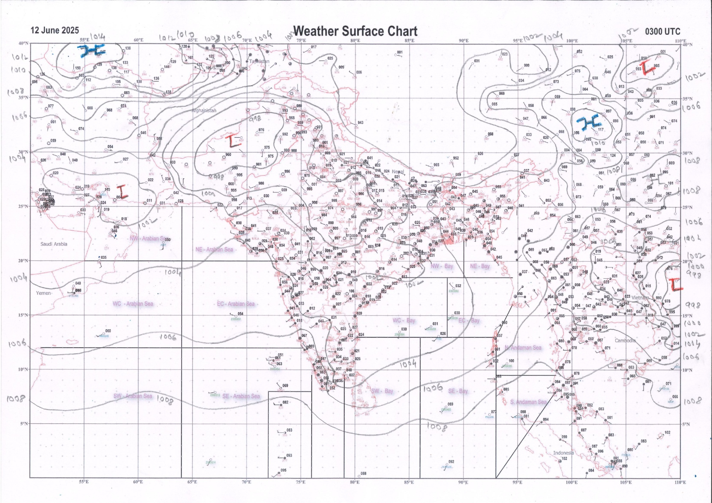 | 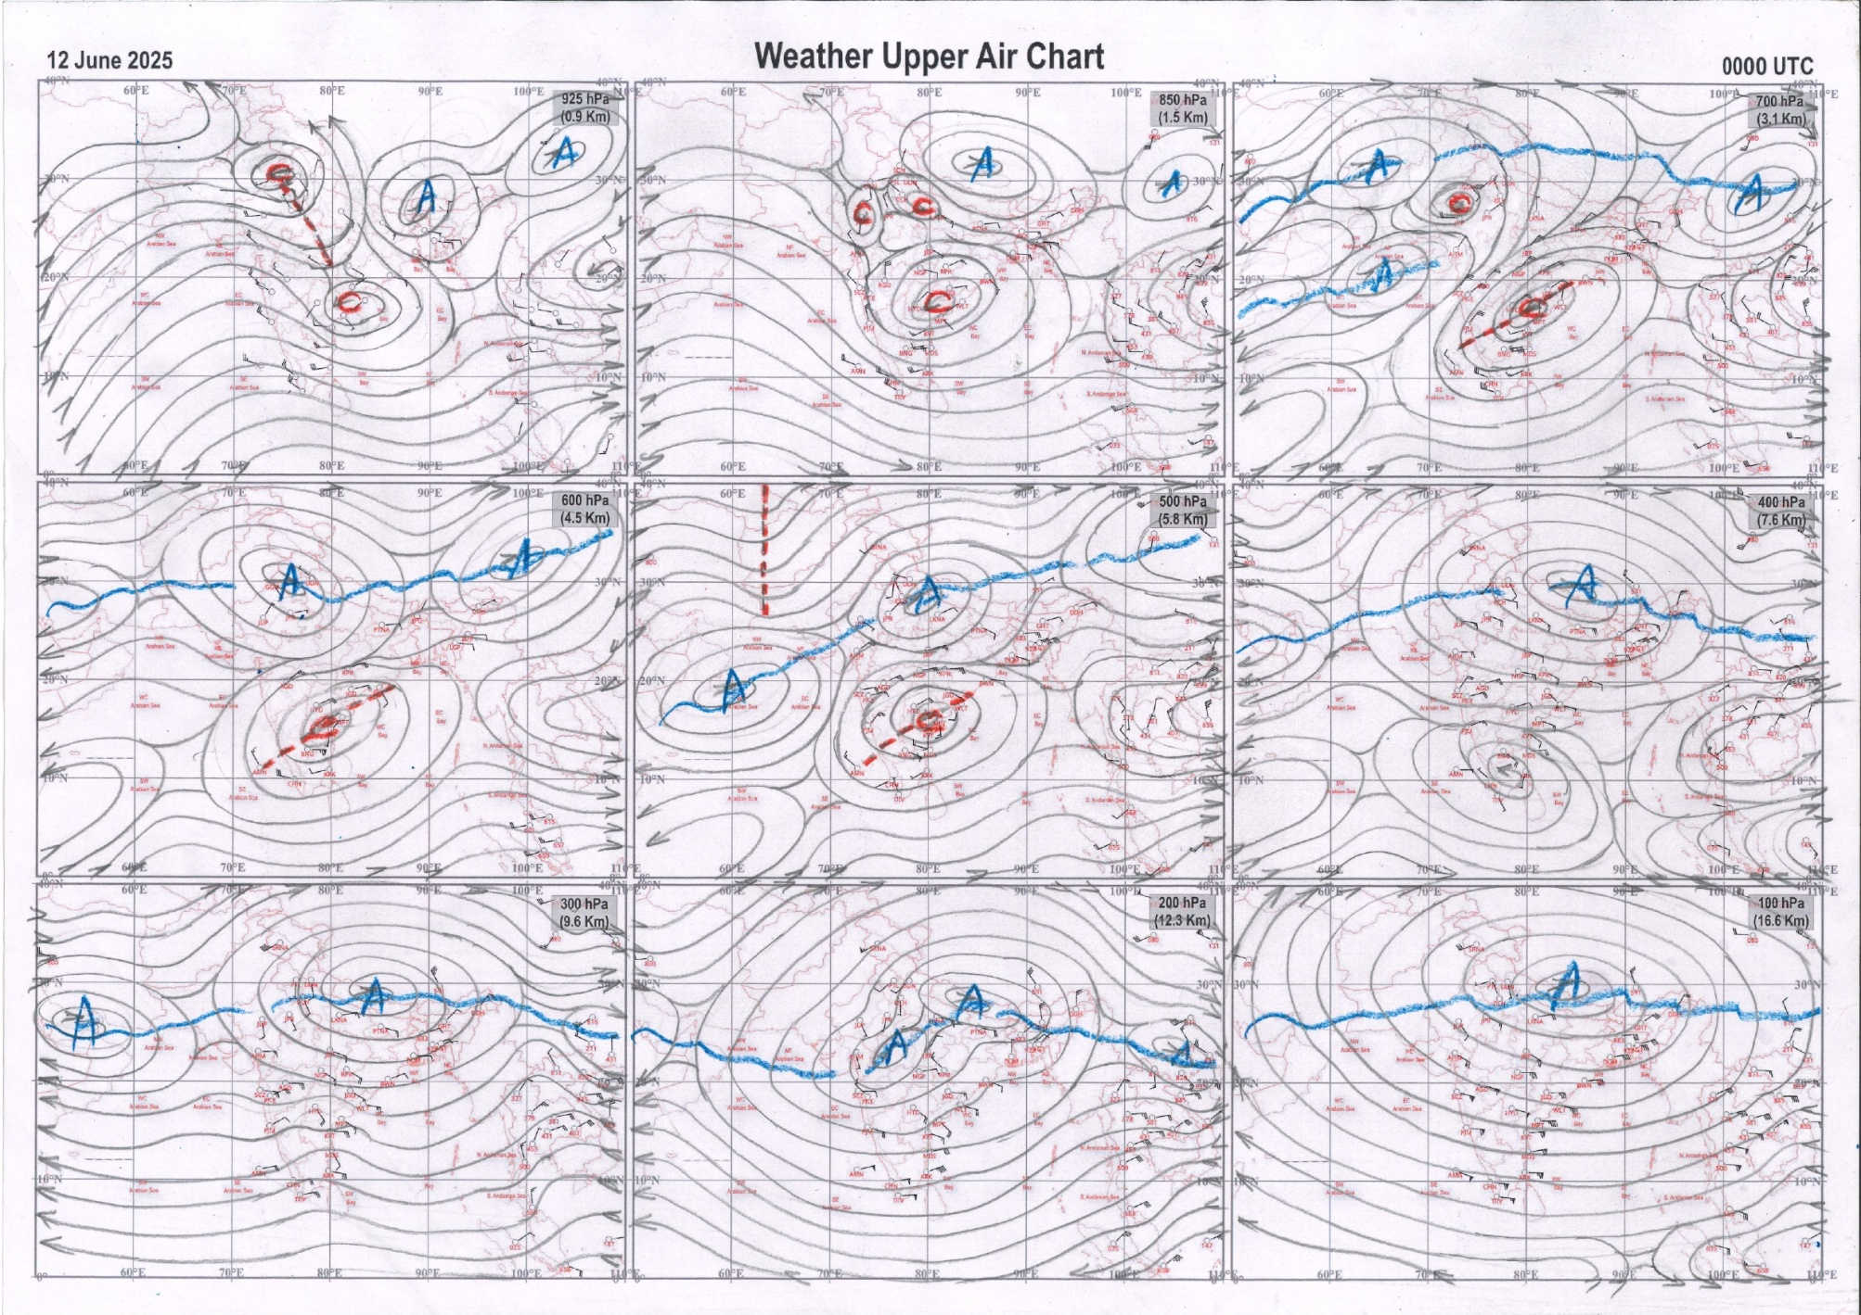
g.1. Analysed surface chart based on 03z observation | Fig.2. Analysed upper air chart based on 00z observation

Dr. S.D.Sanap
Scientist ‘D’
CR & S Office, Pune  Issued at 1245 hrs. IST |  | Weather Forecasting Division  CR&S, Pune

Indian regions | Realised rainfall (chief amount in cm during past 24 hrs):
East | a few places: Assam & Meghalaya+, Nagaland-Manipur-Mizoram-Tripura+, Sub-Himalayan West Bengal & Sikkim and Odisha+  isolated places: Arunachal Pradesh, Gangetic West Bengal, Jharkhand and Bihar  Laharighat ARG 8.3, Bhograi & Chilika 7.2 each, Sabroom 6.7, Ravangla ARG 5.5, Sabroom AWS 5.3, Lumding 5.0, Lumding ARG & Champasari 4.9 each, Bagdogra IAF 4.5, Digha 3.4, Bhubaneswar AP 2.8, Sagar island PTO 1.8, Bhalukpong 1.6, Bankura (CWC) & Tantnagar 1.4 each, Lengpui 1.3, Galgalia 1.2, Manoharpur 1.0, Ziro 0.4, Sikti 0.3, Tuting AWS 0.1.
North | isolated places: east Uttar Pradesh◆, west Uttar Pradesh and Uttarakhand+  dry weather: Haryana, Punjab, Himachal Pradesh, Jammu-Kashmir and Ladakh and Rajasthan  Chamoli 8.8, Sama 6.9, Dharchula 1.3, Konch 0.9.
Central | isolated places: Madhya Pradesh, Vidarbha and Chhattisgarh  Bhamragad 3.2, Punasa dam & Maheshwar 2.6 each, Sausar 2.5, Deolgaon raja 1.8, Bijapur 1.6, Jaisingh Nagar & Kuakonda 1.5 each, Kannod 1.4, Buldana 0.7, Jagdalpur 0.1.
Peninsula | most places: coastal Karnataka#, north interior Karnataka+++ and Kerala+  many places: Konkan & Goa++, Rayalaseema+ and south interior Karnataka+  a few places: Madhya Maharashtra, Marathwada, coastal Andhra Pradesh and Telangana+  isolated places: Tamil Nadu+  dry weather: Gujarat State  Karwar 37.4, Kota 19.1, Kerur 16.0, Hubballi 14.9, Gokarna 14.8, Canacona 13.1, Agumbe emo 10.0, Muliyar AWS 9.4, Bayar AWS 9.2, Gopalpet 8.9, Sanguem & Puducherry 8.3 each, N r pura 8.1, Gadag PBO 7.6, Aiza & Kochi IAF 7.1 each, Devanakonda 6.9, Manthralayam 6.2, Honnali 6.1, Karaikudi 5.8, Mormugao pmo IMD 5.7, Bapatla & Manamelkudi 5.5 each, Pusapatirega 5.2, Karamchedu 5.0, Mahbubnagar 4.7, Georai 3.7, Ahilyanagar IMD pt 3.6, Pachora 3.5, Dharangaon 3.3, Shirur kasar & Nandyal 2.5 each, Beed 2.0.
Islands | most places: Andaman & Nicobar  a few places: Lakshadweep  Port blair 4.5, Maya bandar 4.2, Long island 3.7, Minicoy 0.9.
Table 2. Forecast / warnings (distribution of rain / thundershowers) for 7 days (valid from time of origin upto 0830 hrs IST of next day)
Sr. No |  | Sub-division Name | Day 1 | Day 2 | Day 3 | Day 4 | Day 5 | Day 6 | Day 7 | Sr. No. | Sub-division Name | Day 1 | Day 2 | Day 3 | Day 4 | Day 5 | Day 6 | Day 7
 |  |  | 12 Jun | 13 Jun | 14 Jun | 15 Jun | 16 Jun | 17 Jun | 18 Jun |  |  | 12 Jun | 13 Jun | 14 Jun | 15 Jun | 16 Jun | 17 Jun | 18 Jun
 | 1 | Andaman Nicobar Islands | W+ | W+ | W  | W | F | F | F | 19 | west Madhya Pradesh | I  + | I + | S  | F  | F+ | F + | F
 | 2 | Arunachal Pradesh | I  + | S  + | F +  | F +  | F +  | W + | W +  | 20 | east Madhya Pradesh | I  + | I+ | S  | F+ | F+ | W + | W
 | 3 | Assam-Meghalaya | S  + | S + + | F +  | F + | F ++ | W ++ | W +  | 21 | Gujarat region | I  | I  | I  | S  | S  | S | S 
 | 4 | Nagaland-Manipur-Mizoram-Tripura | S+ | S +  | F+ | F +  | F +  | W ++ | W +  | 22 | Saurashtra and Kutch | I | I | I | I  | S | S | S
 | 5 | Sub Himalayan West Bengal/Sikkim | F  | F+ | W ++ | W + | W | F | F | 23 | Konkan and Goa | W# | W#  | W# | W# | W++ | W ++ | W ++
 | 6 | Gangetic West Bengal | I  | S  | S  | F  | W+ | F + | F | 24 | Madhya Maharashtra | W++ | W++ | W+ | F+ | F++ | F ++ | F +
 | 7 | Odisha | F + | F+ | F+ | F + | W ++ | W + | W + | 25 | Marathwada | F +  | F+ | S + | I  | S  | F | S 
 | 8 | Jharkhand | I  | I  | S  | F  | F  | F | F | 26 | Vidarbha | I  | S  | F+ | F+ | W+ | W + | W +
 | 9 | Bihar | I + | I + | I  | S  | S  | S | S | 27 | Chhattisgarh | I  | I  | S +  | F +  | F +  | F + | F +
 | 10 | east Uttar Pradesh | I + | I+ | S  | S  | S  | S | I  | 28 | Coastal Andhra Pradesh and Yanam | F +  | S+ | F+ | F+ | F+ | S | S
 | 11 | west Uttar Pradesh | I + | I + | I + | I  | S  | S  | S  | 29 | Telangana | F +  | F+ | F+ | F+ | F+ | F + | F
 | 12 | Uttarakhand | F+ | F+ | F+ | F+ | F+ | W+ | W+ | 30 | Rayalaseema | F +  | F + | S  | F | F | S | S
 | 13 | Haryana,Chandigarh and Delhi | I + | I + | I+ | I  | I  | S | S  | 31 | Tamil Nadu, Puducherry and Karaikal | I +  | I ++ | S#  | S# | S ++ | S ++ | I ++
 | 14 | Punjab | D + | D + | I+ | I + | I  | I  | I  | 32 | Coastal Karnataka | W# | W# | W# | W# | W# | W ++ | W #
 | 15 | Himachal Pradesh | D + | D + | D + | I  | S  | S | S  | 33 | North interior Karnataka | W #  | W++ | W++ | W+ | F++ | F ++ | F ++
 | 16 | Jammu-Kashmir and Ladakh | D + | I  + | I+ | I | I | I | I | 34 | South interior Karnataka | W #  | W# | F# | W# | F# | F ++ | F #
 | 17 | west Rajasthan | D + | D + | I + | I+ | I  | I  | I  | 35 | Kerala and Mahe | W++ | W++ | W# | W# | W# | W # | W #
 | 18 | east Rajasthan | D + | I + | I+ | I  | I  | I  | S  | 36 | Lakshadweep | W  | W  | W +  | W+ | W  | W | W
Legends: D = Dry I = Isolated S = Scattered F = Fairly widespread W = Widespread #= heavy to very heavy rain at a few places with extremely heavy rain at isolated places +++= heavy rain at a few places with very heavy rain at Isolated places ++= heavy to very heavy rainfall @=Isolated exceptionally heavy rainfall + = heavy rain ●/*= rain or snow ♦ = very light rain ≡=fog= thunderstorm with lightning =Squall / Gusty / gale / strong wind ­ =cold wave/cold day += heat wave/warm night/hot and humid weathe r=Duststorm =ground frost = Hail

Fig. 4: Districtwise warnings for five days for Maharashtra State
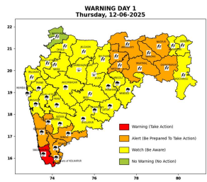 | 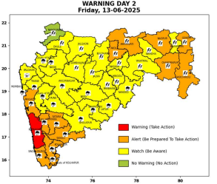 | 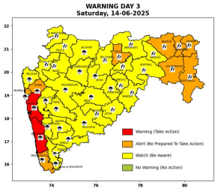 | 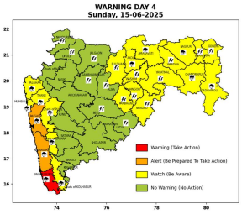 | 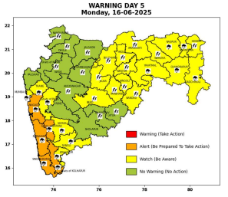

Pune, Lohegaon and Pashan observations at 0830 hrs. IST of Today
 | Temperature (°C) |  |  |  |  | Humidity (%) |  |  |  | Rainfall (mm)
 | Max.  past  24 hrs | Dep.  from  normal | Min.  past  24 hrs. | Dep.  from  normal | Dry  Bulb | At 0830 hrs. IST | Dep.  From  normal | At 1730  hrs. IST of y’day | Dep.  from  normal | Past  24 hrs. | Since  1st June | Dep.  from  normal
PNE | 30.7 | -1.7 | 21.5 | -1.8 | 26.8 | 83 | 6 | 74 | 8 | 5.3 | 43.4 | -18.9
PSN | 29.8 | - | 25.1 | - | 26.2 | 94 | - | 78 | - | 5.2 | 31.5 | -
LHG | 31.9 | -1.1 | 23.9 | 2.9 | 28.5 | 74 | 0.0 | 64 | 5 | 7.0 | 61.8 | 17.5

 |  |  |  |  |  |  | Local (Pune and neighbourhood) forecast
Max./Min. Temperature (°C) |  |  |  |  |  |  |  |  | Weather
Date | Pune | Pashan | Lohegaon | Chinchwad | Lavale | Magarpatta | NDA | Koregoan Park
12/06/25 | 31/21.5* | 30/25.1* | 32/23.9* | 30/23.1* | 30/22.8* | 31/22.6* | 30/22.1* | 31/23.1* | Generally cloudy sky. Light to moderate rain very likely.
13/06/25 | 29/22 | 28/23 | 31/24 | 28/23 | 28/23 | 30/23 | 28/22 | 29/23 | Generally cloudy sky. Light to moderate rain very likely.
14/06/25 | 30/21 | 29/22 | 32/23 | 29/22 | 29/22 | 31/22 | 29/21 | 30/22 | Generally cloudy sky. Light rain very likely.
15/06/25 | 30/22 | 29/23 | 32/24 | 29/23 | 29/23 | 31/23 | 29/22 | 30/23 | Generally cloudy sky. Light rain very likely.
16/06/25 | 29/21 | 28/22 | 31/23 | 28/22 | 28/22 | 30/22 | 28/21 | 29/22 | Generally cloudy sky. Light to moderate rain likely.
17/06/25 | 29/21 | 28/22 | 31/23 | 28/22 | 28/22 | 30/22 | 28/21 | 29/22 | Generally cloudy sky. Light to moderate rain likely.
18/06/25 | 29/20 | 28/21 | 31/22 | 28/21 | 28/21 | 30/21 | 28/20 | 29/21 | Generally cloudy sky. Light to moderate rain likely.
Rainfall Distribution |  |  | Rainfall Categories | Rainfall (mm) |  | Cloud condition |  |  |  | Rainfall Intensity |  | Range
Widespread (W) | 76-100% |  | Very Light rain | Trace to 2.4 mm |  | Mainly clear sky |  | 1-2 oktas |  | Light Spell |  | 1 cm/hr
 |  |  | Light rain | 2.5 to 15.5 mm |  | Partly cloudy sky |  | 3-4 oktas |  | Moderate Spell |  | 1-2 cm/hr
Fairly Widespread (FW) | 51 – 75% |  | Moderate rain | 15.6 to 64.4 mm |  | Generally cloudy sky |  | 5-7 oktas |  | Intense Spell |  | 2-3 cm/hr
Scattered (S) | 26 – 50% |  | Heavy rain | 64.5 to 115.5 mm |  | Overcast |  | 8 oktas |  | Very Intense Spell |  | 3-5 cm/hr
isolated (I) | 1 – 25% |  | Very heavy rain | 115.6 to 204.4 mm |  |  |  |  |  | Extremely Intense Spell |  | 5-10 cm/hr
D (D) | No Rain |  | Extremely heavy rain | ≥ 204.5 mm |  |  |  |  |  | Cloudburst |  | > 10 cm/hr
Probability Terms in %: |  |  | Heavy snow | 6.5 to 11.5 cms water equivalent of rain
unlikely | < 25 |  | Very heavy snow | 11.6 to 20.4 cms water equivalent of rain
likely | between 25 50
very likely | between 51 75
most likely | >75
* = realized temperature
Mumbai (Colaba) |  |  |  | Nagpur (AP)
Date 2025 | T max °C | T min °C | Weather | T max °C | T min °C | Weather
12/06 | 32 | 27 | Partly cloudy sky with possibility of moderate rain or thundershowers accompanied with lightning & gusty winds(40-50kmph). | 38 | 28 | Rain or thundershowers accompanied with lightning & gusty winds(40-50kmph).
13/06 | 32 | 27 | Generally cloudy sky with Heavy rain. | 39 | 27 | Rain or thundershowers accompanied with lightning & gusty winds(40-50kmph).
14/06 | 32 | 26 | Generally cloudy sky with Heavy rain. | 40 | 25 | Rain or thundershowers accompanied with lightning & gusty winds(50-60kmph).
15/06 | 32 | 26 | Generally cloudy sky with Heavy rain. | 40 | 24 | Heavy rain or thundershowers accompanied with lightning & gusty winds(40-50kmph).
16/06 | 31 | 25 | Generally cloudy sky with Heavy rain. | 40 | 24 | Rain or thundershowers accompanied with lightning & gusty winds(40-50kmph).
17/06 | 31 | 24 | Rain. | 40 | 23 | Partly cloudy sky with thundery development.
18/06 | 30 | 23 | Rain. | 39 | 23 | Partly cloudy sky with thundery development.

